Health Analysis

Lynn Ajema

2023-09-26

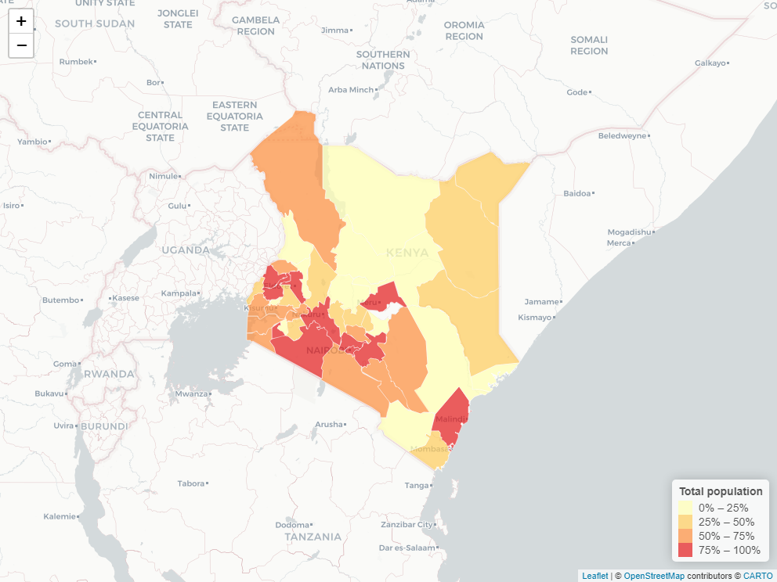

#Health Analysis

How many count have level 5/6 hospitals

Count of Level 5/6 Hospitals by County

| COUNTY | Health_LV5 |
| --- | --- |
| Embu | 1 |
| Garissa | 1 |
| Homa Bay | 1 |
| Kakamega | 1 |
| Kiambu | 3 |
| Kisii | 2 |
| Kisumu | 1 |
| Machakos | 1 |
| Mandera | 1 |
| Meru | 1 |
| Mombasa | 1 |
| Nairobi | 7 |
| Nakuru | 1 |
| Nandi | 1 |
| Nyeri | 2 |
| Trans Nzoia | 1 |
| Uasin Gishu | 1 |

## 

## Bar charts showing Level 4 Hospital Distribution by counties

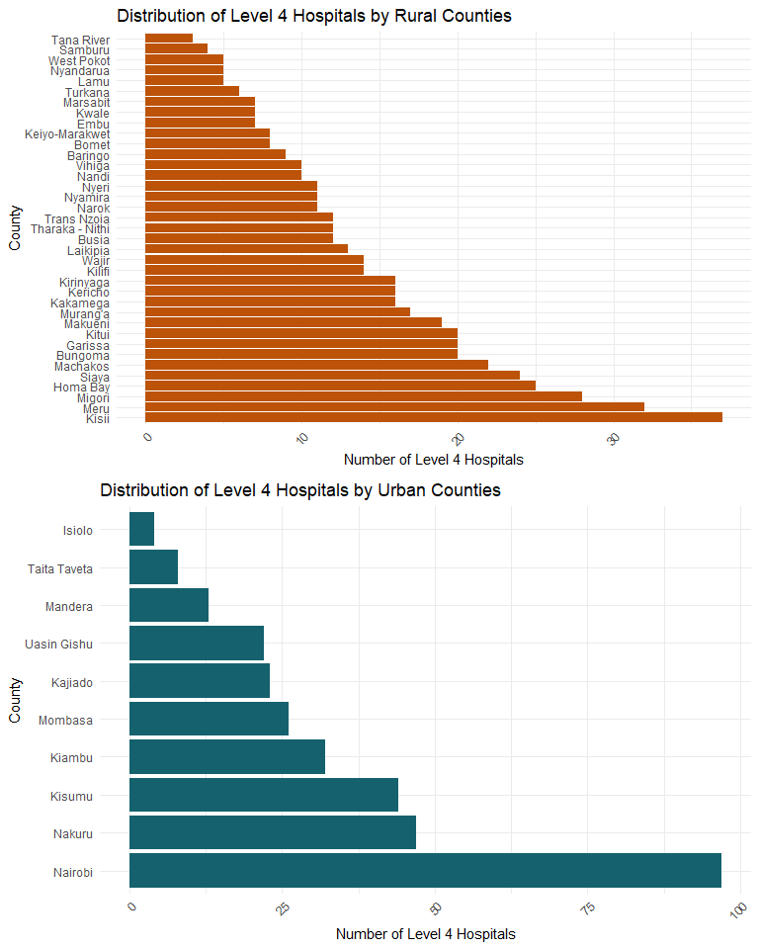

**Bar charts showing Level 3 Hospital Distribution by counties** 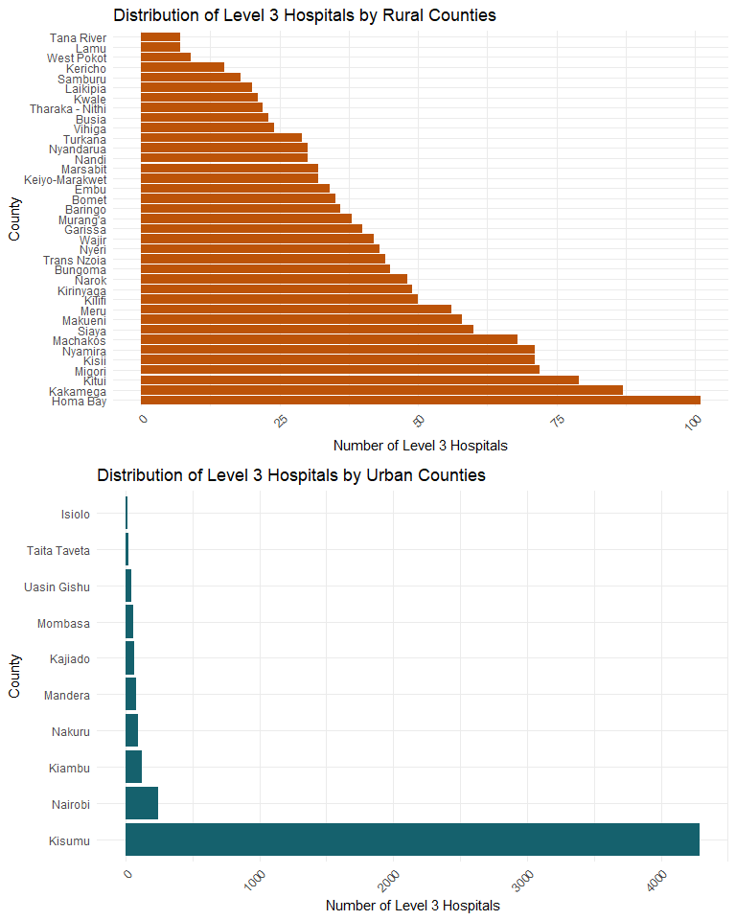

**Bar charts showing Level 2 Hospital Distribution by counties** 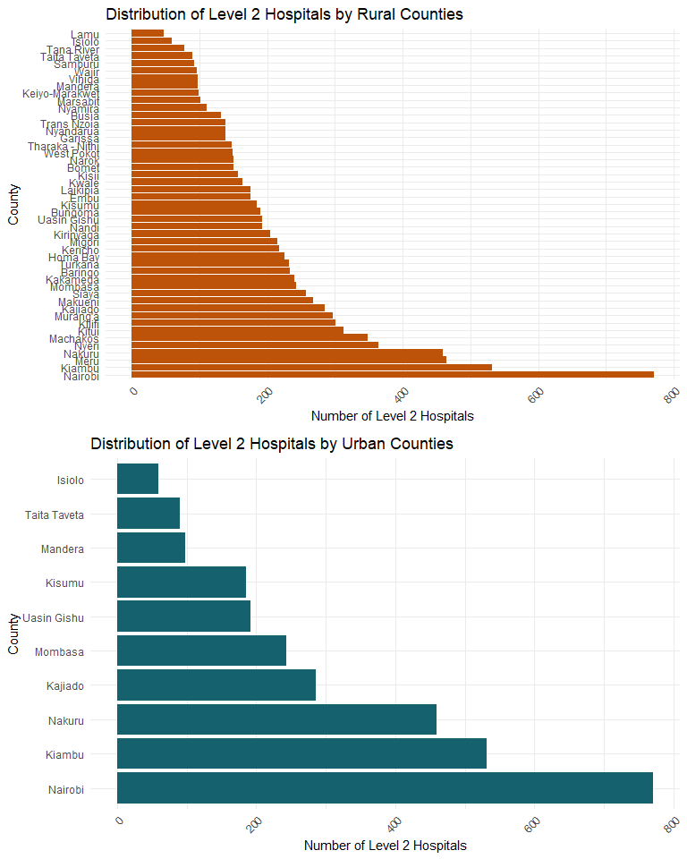

**Bar charts showing Hospital Bed density per 10000 population by counties** 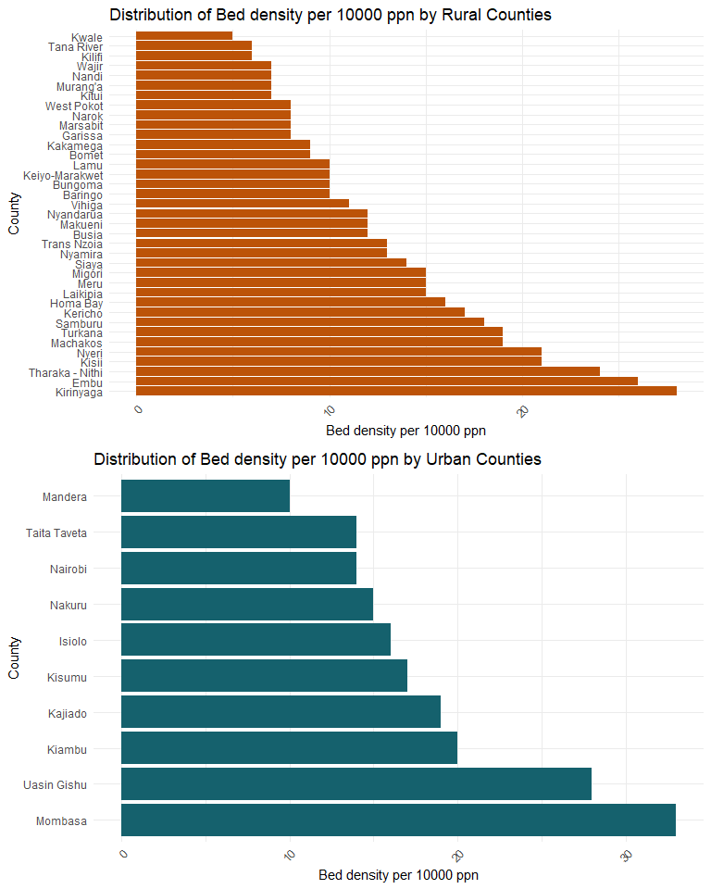

**Barcharts showing Hospital worker per 10000 population Distribution by counties** 